We have a x64 PE file

Throw it into IDA

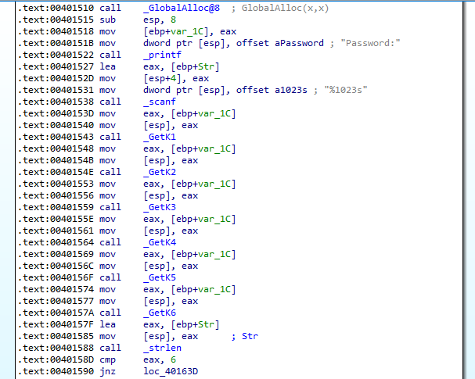

-First, it requires password

After that, it call 6 function, to create something which stored in var_1C (go deeper into each function you will see that)

-Second, it checks length of password you have entered

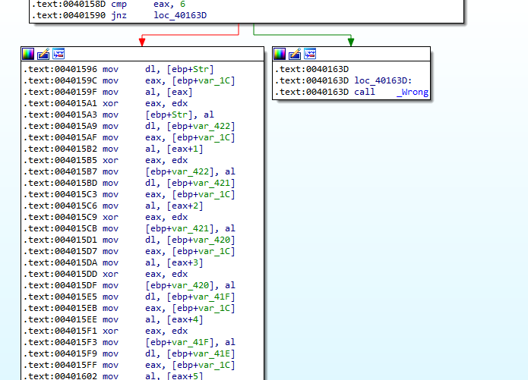

if length equal 6, it starts checking your password by enxor the password with string stored in var_1C

then compare with Str2 which is a hardcoded string

If equal, it call _ShowFlag else call _Wrong

-Debug it, you will get 2 string stored in var_1C and Str2

-Enxor them, you get the password

-Enter the password, you get the Flag

-Script for password:

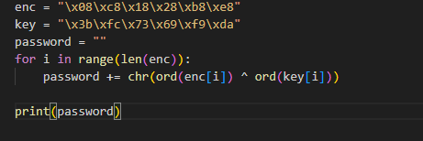

(password: 34kAA2)

FLAG-l2nxcas98q23m6spoqy32k12pa

You can also reverse the _ShowFlag function to get the Flag(another hardcoded string enxor )